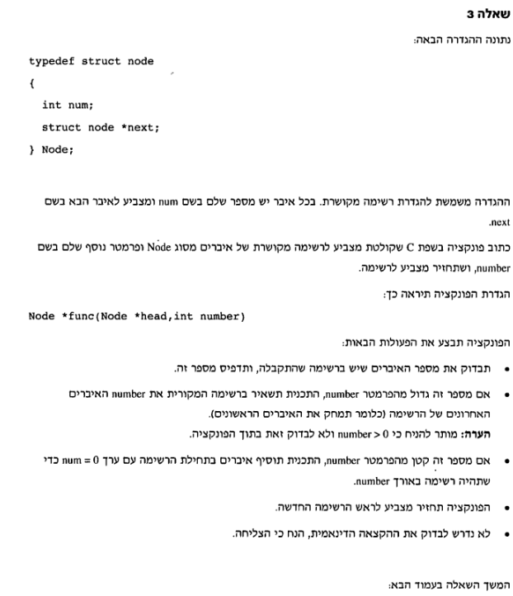

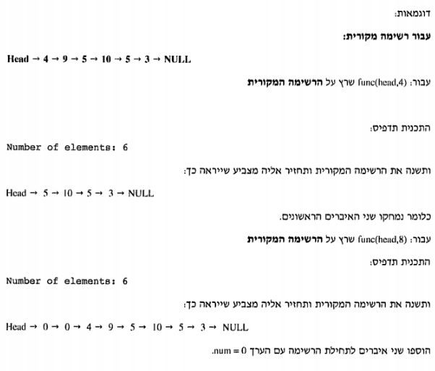

//Changing list by input number

Node \*func(Node \*head, int number)

{

int count=0,i;

Node \*ptr = NULL,\*temp=NULL;

ptr = head;

while (ptr != NULL)

{

count++;

ptr = ptr->next;

}

printf("\nNumber of elements in the list: %2d\n", count);

if (count > number)

{

ptr = head;

for (i = 0; i < (count - number); i++)

{

temp = ptr;

ptr = ptr->next;

free(temp);

}

head = ptr;

}

else

{

for (i = 0; i < (number - count); i++)

{

temp = (node \*)calloc(1,sizeof(node));

temp->num = 0;

temp->next = head;

head = temp;

}

}

return head;

}